LEAF SPRINGS
WONDEE
AUTOPARTS

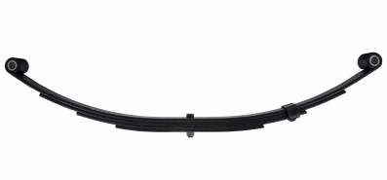
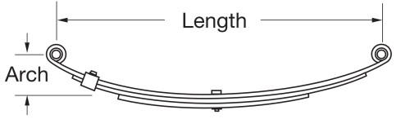
DOUBLE EYE - 1 3/4" WIDE
A
B

PART NUMBER | DESCRIPTION |  |  |  | PACKING |  |  | REFERENCE NUMBERS
 | NUMBER  OF LEAFS | CAPACITY  OF LEAVVES/lb. | FREE  LENGTH /" (A） | FREE  ARCH /"（B） | UNIT  WEIGHT/lb. | PALLET  WEIGHT/lb. | PALLET  QUANTITY/pc.
WD-041M | 3 | 1500 | 20.00" | 3.25" | 9.40 lb. | 1,878 lb. | 200 pc.
WD-7216 | 3 | 700 | 20.31 | 3.38 | 6.1 | 1220.00 | 200.00 | UNA-168,DX-720
WD-7217 | 3 | 1000 | 20.38 | 3.18 | 7 | 1400.00 | 200.00 | UNA-169, X1020
WD-7213 | 4 | 1400 | 20.50 | 3.38 | 9.3 | 1860.00 | 200.00 | UNA-167
WD-726 | 3 | 1250 | 23.13 | 3.63 | 9.1 | 1820.00 | 200.00 | UNA-135
WD-729 | 3 | 1750 | 23.13 | 3.50 | 11 | 2200.00 | 200.00 | UNA-216, 1724-3L
WD-7218 | 4 | 2000 | 23.13 | 3.50 | 12.4 | 2480.00 | 200.00 | UNA-170, WAH-4
WD-113 | 3 | 1000 | 23.50 | 3.50 | 9.3 | 1860.00 | 200.00 | UNA-113, 545-3L
WD-114 | 4 | 1400 | 23.50 | 3.50 | 10.7 | 2134.00 | 200.00 | UNA-114, 545-4L
WD-7227 | 6 | 3500 | 24.88 | 3.38 | 18.3 | 2738.00 | 150.00 | UNA-222, 1769
WD-7222 | 3 | 1250 | 25.25 | 3.18 | 9.6 | 1920.00 | 200.00 | UNA-219, SW3B
WD-7242 | 4 | 1750 | 25.25 | 3.00 | 11.7 | 2348.00 | 200.00 | UNA-212, SW4B SW4B,
WD-SW4B | 4 | 1750 | 25.25 | 3.00 | 11.7 | 2340.00 | 200.00 | 93184
WD-7226 | 4 | 3000 | 25.13 | 3.13 | 15.4 | 3080.00 | 200.00 | UNA-221
WD-7223 | 3 | 1500 | 25.25 | 3.00 | 11 | 2200.00 | 200.00 | UNA-217
WD-7224 | 3 | 2000 | 25.25 | 3.00 | 12.3 | 2458.00 | 200.00 | UNA-220, 1762, SW3
WD-7225 | 4 | 2500 | 25.25 | 3.00 | 15.1 | 3014.00 | 200.00 | UNA-218, 1763, SW4
WD-1764 | 5 | 2900 | 25.25 | 3.00 | 17 | 2125.00 | 125.00 | UNA-111, 1764, SW5
WD-SW3 | 3 | 1750 | 25.25 | 3.00 | 11.7 | 2340.00 | 200.00 | UNA-220, 1762, 72-24
WD-SW4 | 4 | 2500 | 25.25 | 3.00 | 13.8 | 2760.00 | 200.00 | UNA-218, 1763, 72-25
WD-SW5 | 5 | 2950 | 25.25 | 3.00 | 16.3 | 2038.00 | 125.00 | UNA-111, 1764
WD-SW6 | 6 | 3500 | 25.25 | 3.00 | 19.1 | 2388.00 | 125.00 | UNA-223, SW6
WD-26350 | 2 | 350 | 26.00 | 4.13 | 7 | 1400.00 | 200.00 | UNA-121, 26-350, AS2
WD-26500 | 3 | 500 | 26.00 | 4.12 | 9.1 | 1820.00 | 200.00 | UNA-122, 25-500, AS3
WD-261000 | 4 | 1000 | 26.00 | 4.12 | 11.1 | 2220.00 | 200.00 | UNA-124, 26-1000,
WD-AWS2 | 2 | 1000 | 26.00 | 4.25 | 9.9 | 1972.00 | 200.00 | AS4 UNA-049, AWS2
WD-AWS3 | 3 | 1500 | 26.00 | 4.25 | 12 | 2394.00 | 200.00 | UNA-050, AWS3
WD-AWS4 | 4 | 2000 | 26.00 | 4.25 | 14 | 2798.00 | 200.00 | UNA-051, AWS4
WD-AWS5 | 5 | 2500 | 26.00 | 4.25 | 17.1 | 2134.00 | 125.00 | UNA-052, AWS5
WD-AWS6 | 6 | 3000 | 26.00 | 4.25 | 20.3 | 2538.00 | 125.00 | UNA-053, AWS6
WD-AWS7 | 7 | 3500 | 26.00 | 4.25 | 23.4 | 3043.00 | 130.00 | UNA-054, AWS7
WD-AWS8 | 8 | 4000 | 26.00 | 4.25 | 27.2 | 3400.00 | 125.00 | UNA-055, AWS8
WD-33611 | 3 | 750 | 27.00 | 3.50 | 9.1 | 1820.00 | 200.00 | UNA-144, 15327
WD-33612 | 3 | 1000 | 27.00 | 2.88 | 10.1 | 2022.00 | 200.00 | UNA-141, 20327
WD-33613 | 4 | 2100 | 27.00 | 2.88 | 14 | 2800.00 | 200.00 | UNA-210, 35427
WD-33617 | 6 | 3000 | 27.00 | 3.25 | 22.3 | 2788.00 | 125.00 | UNA-142, 60627
WD-45527 | 5 | 2250 | 27.00 | 2.75 | 17.3 | 2158.00 | 125.00 | UNA-234, 45527

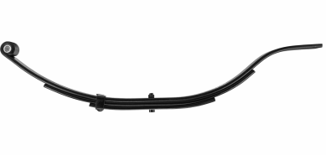
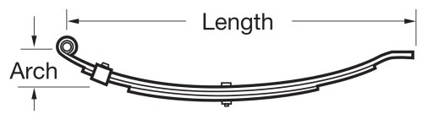
Slipper leaf spring flat 1-3/4"
A
B
PART NUMBER | DESCRIPTION |  |  |  | PACKING |  |  | REFERENCE NUMBERS
 | NUMBER  OF LEAFS | CAPACITY  OF LEAVVES/lb. | FREE  LENGTH /" (A） | FREE  ARCH /"（B） | UNIT  WEIGHT/lb. | PALLET  WEIGHT/lb. | PALLET  QUANTITY/pc.
WD-047 | 3 | 1,675 | 24.50 | 4.12 | 11 | 2200.00 | 200.00 | UNA-047
WD-013 | 2 | 500 | 25.12 | 5.00 | 5.8 | 1450.00 | 250.00 | UNA-013
WD-014 | 3 | 750 | 25.12 | 5.00 | 7.9 | 1975.00 | 250.00 | UNA-014
WD-015 | 4 | 1000 | 25.12 | 5.00 | 9.5 | 2375.00 | 250.00 | UNA-015
WD-432110 | 2 | 950 | 30.00 | 4.88 | 10.1 | 2020.00 | 200.00 | UNA-038, WD-2
WD-433115 | 3 | 1500 | 30.00 | 4.88 | 12.5 | 6250.00 | 500.00 | UNA-039, WF-3
WD-434117 | 4 | 2000 | 30.00 | 4.88 | 12.2 | 2440.00 | 200.00 | UNA-040, WG-4
WD-434118 | 5 | 2400 | 30.00 | 4.88 | 18.3 | 2745.00 | 150.00 | UNA-040N, WG-5

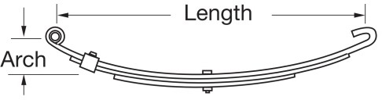
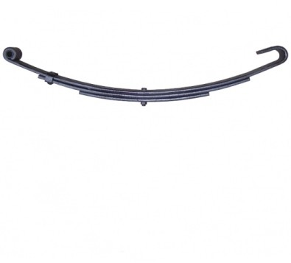
SLIPPER OPEN – 1 3/4" WIDE
A
B

PART NUMBER | DESCRIPTION |  |  |  | PACKING |  |  | REFERENCE NUMBERS
 | NUMBER OF LEAFS | CAPACITY OF LEAVVES/lb. | FREE LENGTH /" (A） | FREE  ARCH /"（B） | UNIT WEIGHT/lb. | PALLET WEIGHT/lb. | PALLET QUANTITY/pc.
WDSO-C1 | 2 | 800 | 26.25 | 3.50 | 8.3 | 2075.00 | 250.00 | SO-C1，UNA-261，C1
WDSO-C2 | 3 | 1,300 | 26.25 | 3.50 | 10.7 | 2140.00 | 200.00 | SO-C2，UNA-262，C2
WDSO-C3 | 3 | 1,750 | 26.25 | 3.50 | 12.1 | 2428.00 | 200.00 | SO-C3，UNA-263，C3
WDSO-C4 | 4 | 2,350 | 26.25 | 3.50 | 14.9 | 2974.00 | 200.00 | SO-C4，UNA-264，C4
WDSO-C5 | 5 | 2,850 | 26.25 | 3.50 | 17.4 | 2613.00 | 150.00 | SO-C5，UNA-265，C5
WDSO-C6 | 6 | 3,500 | 26.25 | 3.50 | 21.3 | 2661.00 | 125.00 | SO-C6，UNA-211，C6
WDSO-C21.03 | 3 | 1,300 | 26.25 | 3.50 | 10.7 | 2140.00 | 200.00 | SO-C21.03，C-2
WDSO-C31.03 | 3 | 1,750 | 26.25 | 3.50 | 12.1 | 2428.00 | 200.00 | SO-C31.03，C-3
WDSO-C41.03 | 4 | 2,350 | 26.25 | 3.50 | 14.9 | 2974.00 | 200.00 | SO-C41.03，C-4
WDSO-C51.03 | 5 | 2,850 | 26.25 | 3.50 | 17.4 | 2613.00 | 150.00 | SO-C51.03，C-5
WDSO-C61.03 | 6 | 3,500 | 26.25 | 3.50 | 21.3 | 2661.00 | 125.00 | SO-C61.03，C-6

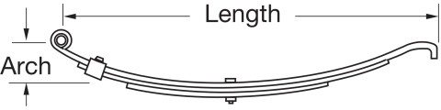
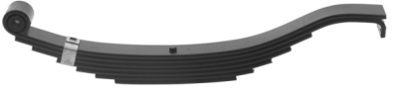
SLIPPER HOOK – 2" WIDE
A
B

PART NUMBER | DESCRIPTION |  |  |  | PACKING |  |  | REFERENCE NUMBERS
 | NUMBER  OF LEAFS | CAPACITY  OF LEAVVES/lb. | FREE  LENGTH /" (A） | FREE  ARCH /"（B） | UNIT  WEIGHT/lb. | PALLET  WEIGHT/lb. | PALLET  QUANTITY/pc.
WDSH-7229 | 4 | 1,500 | 26.50 | 3.18 | 15.8 | 2366.00 | 150.00 | SH-7229,UNA-229,60-3T3
WDSH-7230 | 4 | 2,000 | 26.50 | 3.00 | 16.4 | 2460.00 | 150.00 | SH-7230,UNA-230,80-3T3
WDSH-7231 | 4 | 2,500 | 26.50 | 3.06 | 17.6 | 2640.00 | 150.00 | SH-7231,UNA-231,100-3T3
WDSH-7232 | 5 | 3,500 | 26.50 | 3.18 | 20.4 | 2550.00 | 125.00 | SH-7232,UNA-232,120-3T3
WDSH-7232RB | 5 | 3,500 | 26.50 | 3.18 | 20.5 | 2563.00 | 125.00 | SH-7232,120-3T3 RB
WDSH-7233 | 7 | 4,000 | 26.50 | 3.00 | 27 | 3375.00 | 125.00 | SH-7233,UNA-233,140-3T3
WDSH-E5226 | 5 | 3,400 | 26.50 | 3.50 | 20.5 | 2563.00 | 125.00 | SH-E5226,UNA-160,5226
WDSH-E5115 | 6 | 4,300 | 29.50 | 3.50 | 28.7 | 2870.00 | 100.00 | SH-E5115,UNA-161,5115

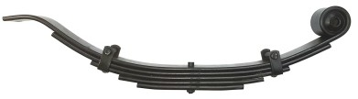
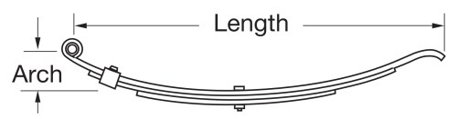
SLIPPER RADIUS – 1 3/4" WIDE
A
B

PART NUMBER | DESCRIPTION |  |  |  | PACKING |  |  | REFERENCE NUMBERS
 | NUMBER  OF LEAFS | CAPACITY  OF LEAVVES/lb. | FREE  LENGTH /" (A） | FREE  ARCH /"（B） | UNIT  WEIGHT/lb. | PALLET  WEIGHT/lb. | PALLET  QUANTITY/pc.
SR-WC1 | 1 | 280 | 24.62 | 4.50 | 4.2 | 1050.00 | 250.00 | SR-WC1,UNA-176, WC-1
SR-WC2 | 2 | 550 | 24.62 | 4.50 | 5.4 | 1350.00 | 250.00 | SR-WC2,UNA-177, WC-2
SR-WE3 | 3 | 750 | 24.62 | 4.50 | 7.8 | 1558.00 | 200.00 | SR-WE3,UNA-178, WE-3
SR-WH4 | 4 | 1,000 | 24.62 | 4.50 | 9 | 1800.00 | 200.00 | SR-WH4,UNA-179, WH-4
SR-WI5 | 5 | 1,200 | 24.62 | 4.50 | 12.1 | 2420.00 | 200.00 | SR-WI5,UNA-180, WI-5
SR-028 | 2 | 600 | 32.00 | 4.25 | 7.8 | 1558.00 | 200.00 | SR-028,UNA-028
SR-034 | 3 | 800 | 32.00 | 4.25 | 10.9 | 2180.00 | 200.00 | SR-034,UNA-034
SR-024 | 4 | 1,100 | 32.00 | 4.25 | 12.4 | 2480.00 | 200.00 | SR-024,UNA-024
SR-029 | 5 | 1,400 | 32.00 | 4.25 | 14.4 | 2920.00 | 200.00 | SR-029,UNA-029
SR-029N | 6 | 1,750 | 32.00 | 4.25 | 18.3 | 2745.00 | 150.00 | SR-029N,UNA-029N

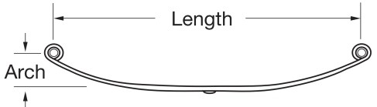
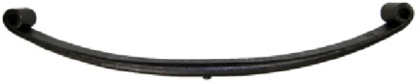
MOBILE HOME – 1 3/4" WIDE
A
B

PART NUMBER | DESCRIPTION |  |  |  | PACKING |  |  | REFERENCE NUMBERS
 | NUMBER  OF LEAFS | CAPACITY  OF LEAVVES/lb. | FREE  LENGTH /" (A） | FREE  ARCH /"（B） | UNIT  WEIGHT/lb. | PALLET  WEIGHT/lb. | PALLET  QUANTITY/pc.
WDDE-7240 | 1 | 3,000 | 25.25 | 3.00 | 8.7 | 3826.00 | 440.00 | DE-7240,UNA-115, 72-40, TE-30

WD-46-SH2 WD-46-SH1

